hw_12

1. **Generative adversarial networks are widely used. Which of the following task(s) can use such networks? (a, b, c, d)**
   1. Image generation
   2. Semantic generation
   3. Data augmentation
   4. Information retrieval
2. **Choose the right description(s) of DCGAN Networks.(a, b)**
   1. Using Batchnorm for both Generator and Discriminator.
   2. Remove all fully-connected layers.
   3. Discriminator uses ReLU activation function for layer except output.
   4. Generator uses LeakyReLU for all layers.
3. **Below are some of the DCGAN torch codes. Choose the right one for the blanks.(d)**

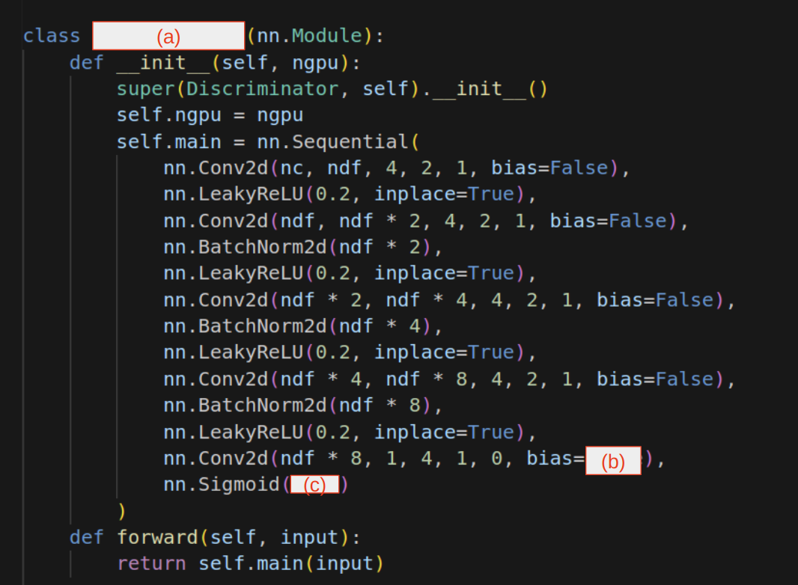

* 1. (a) Generator, (b) true, (c) none
  2. (a) Discriminator, (b) true, (c) false
  3. (a) Generator, (b) false, (c) true
  4. (a) Discriminator, (b) false, (c) none
  5. (a) Discriminator, (b) true, (c) true

1. **Choose the problem(s) that can occur when learning the GAN model.(d, e)**
   1. The model parameters oscillate, destabilize and converge in the wrong direction.
   2. The generator collapses which produces infinite varieties of samples.
   3. Unbalance between the generator and discriminator causing underfitting
   4. Highly sensitive to the hyper-parameter selections.
   5. The discriminator gets too successful that the generator gradient vanishes and learns nothing.
2. **In which way(s) is it proper to update the GAN model?(b, c)**
   1. Update generator by ascending its stochastic gradient
   2. Update generator by descending its stochastic gradient
   3. Update discriminator by ascending its stochastic gradient
   4. Update discriminator by descending its stochastic gradient